My Coaching Philosophy

In helping clients move forward and upwards towards their most valued personal and professional objectives I emphasize two distinct parts to the performance equation:

Technical Skills and Leadership Skills

The first part of the equation represents the technical aspect of the discipline/profession you are engaged in, which is unique and distinct (i.e., medicine, law, engineering, tennis, painting, theater…). The second part of the performance equation represents the human aspect of the discipline/profession you are engaged in, which are relevant across disciplines.
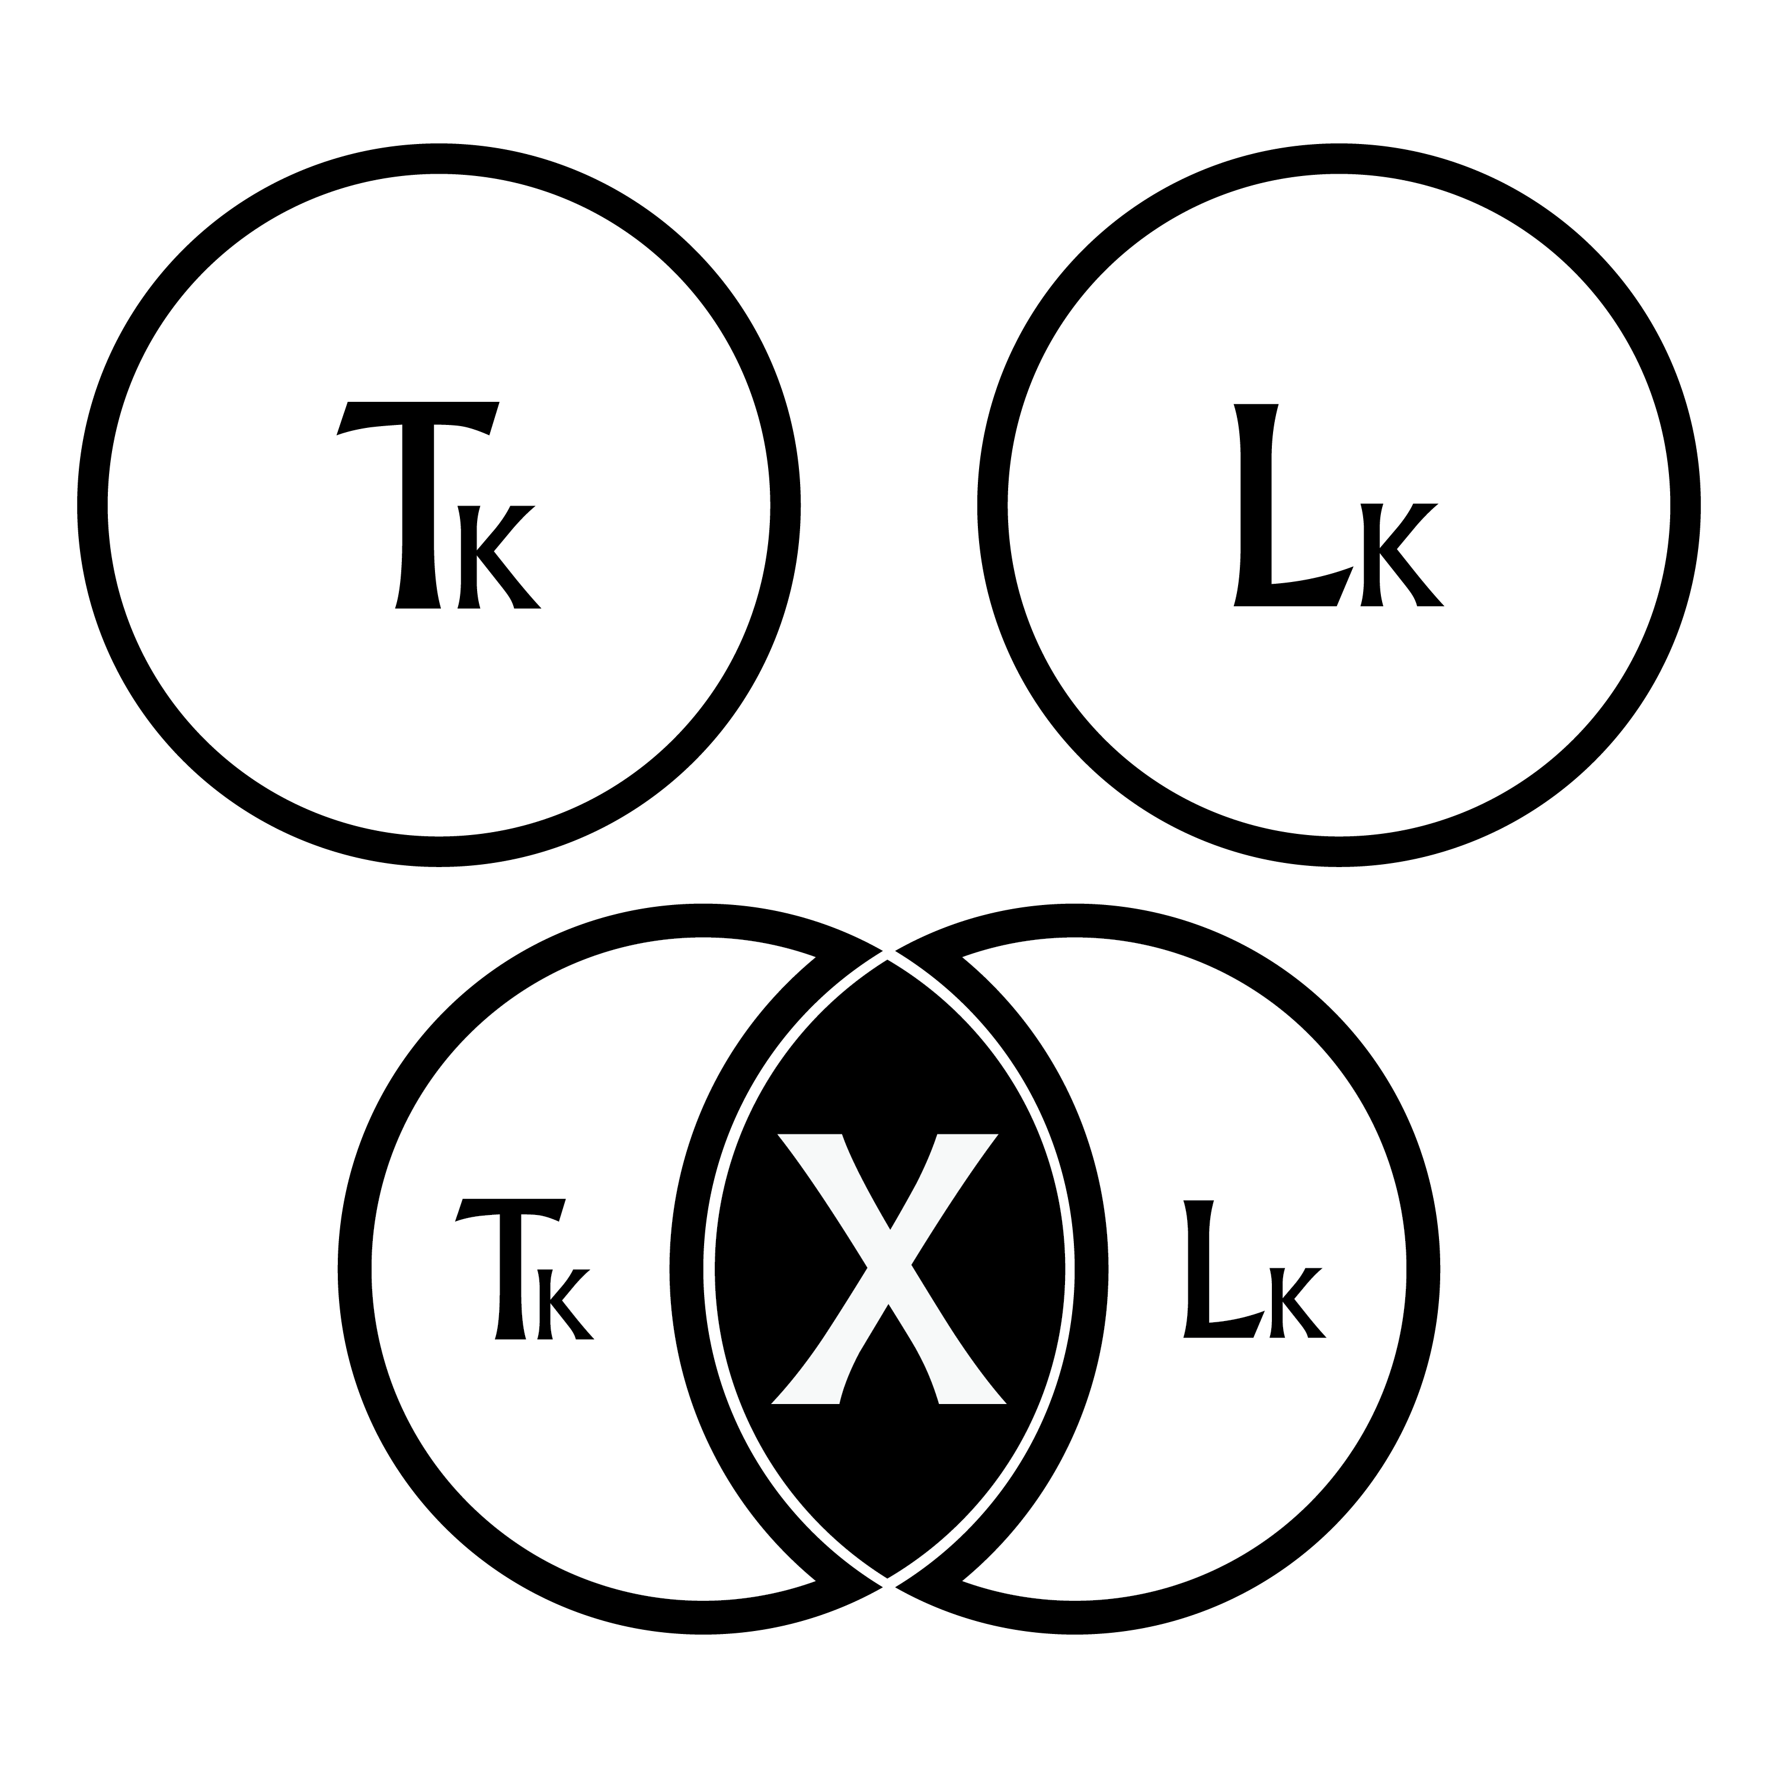
These skills and competencies represent three core dimensions (Internal, Time, and External), for which a more robust two-dimensional model is offered. This model explores five Internal themes: Physical, Emotional, Psychological, Philosophical, and Spiritual dimensions; five Time-based dimensions: Long-Future, Short-Future, Focus/Execution, Short-Past, and Long-Past; and five External dimensions: Personal, Interpersonal, Team, Organization, and Community.

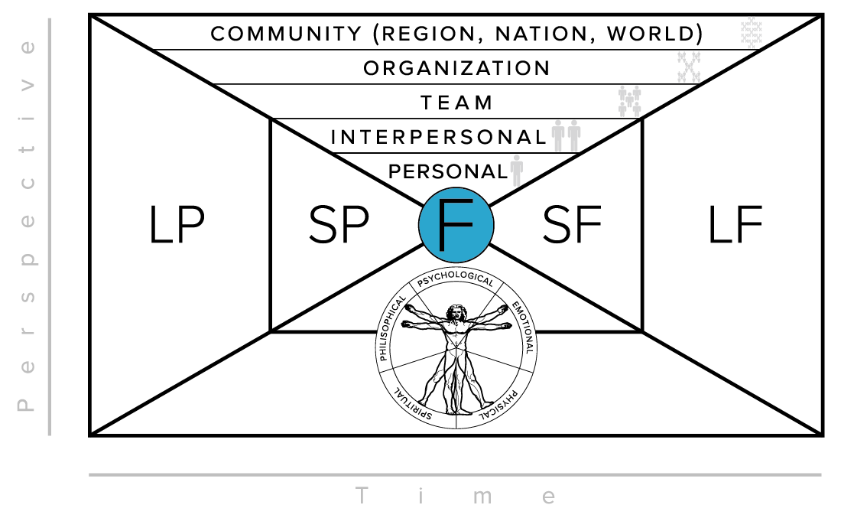
Together these intersecting dimensions provide a bounding and binding framework from which to explore leadership development and performance more dynamically and comprehensively.
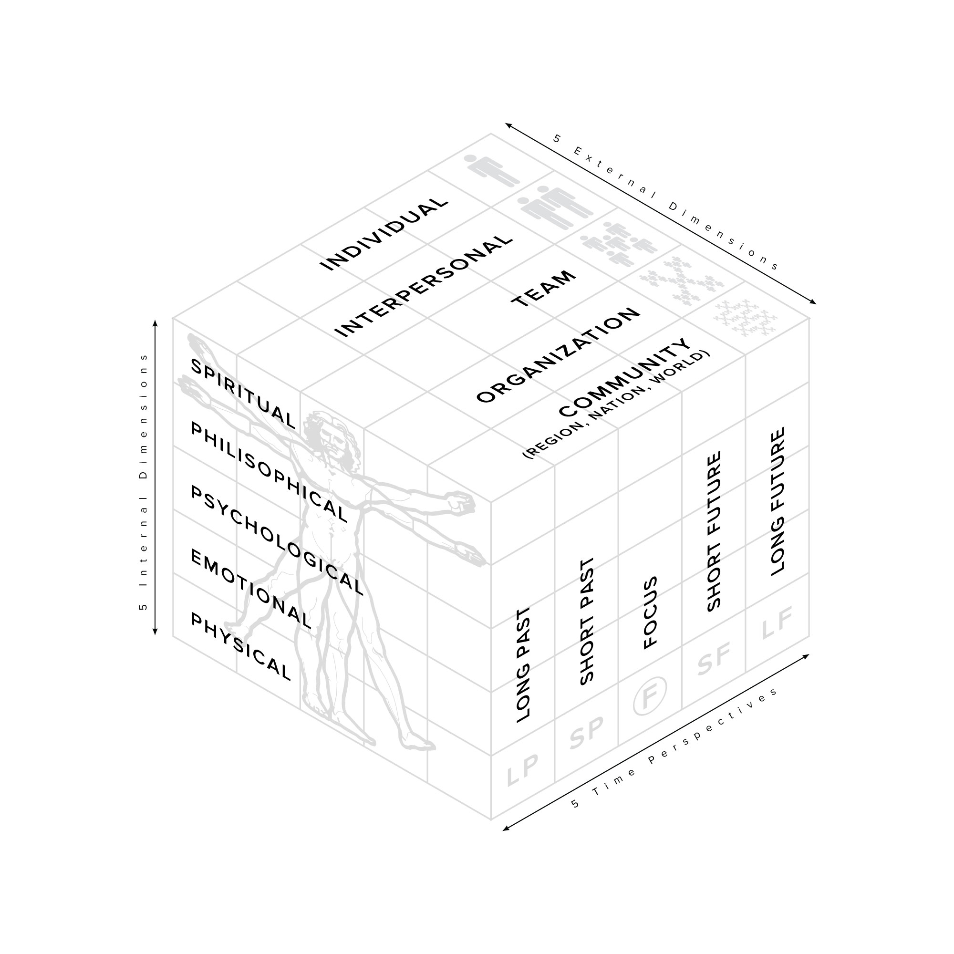
When seeking to up your profession/game/discipline, there are essential technical and leadership competencies that are “core” to your success. There are others—based on your specific your roles—that set you apart from others in your field.

When working with clients, my goal is to understand both sides of your performance equation and to help you recognize what skills and competencies that will help differentiate you, are essential for your success, and most importantly, help you find your best self through your professional craft.

I coach from the perspective of Attentional Leadership™, which states that growing your capacity as a leader is based on what, where, and how long you pay attention in order to solve problems and close vital performance gaps that you are experiencing now.

Together, in a co-creative relationship, we work together to identify your WIN (What’s Important Now) in order to place your “Attention with Intention” to close those gaps and to help you emerge better, wiser, and stronger than you were before.

Through diligent up front data gathering (often including the appropriate assessments), we explore where you’ve been, where you are, and where you want to go. We then generate the missions and vision for our work together, set specific objectives, design a concrete plan, identify the objective measures and milestones, and then get to work.

Working with clients, I typically work in 3-6 month increments with 1-3 significant goals to be achieved during that time. If the expected progress is made during this time, we can work on your next most important WIN’s until I’ve worked myself out of a job or until we have stopped making the progress you want. A new level of effectiveness is expected at each stage of our work together.

By keeping you focused on your win WIN (What’s Important Now), my goal is to help you move the needle on your most important goals within a defined performance arena, and to help you remain committed and focused on achieving your most important personal and professional life missions. In short: my product is your performance!

Ten beliefs serve as a foundation to my coaching philosophy. That…

- We are born with a unique genetic, cultural, social, and personal history. As such, we are designed to fulfill our unique potential and purpose through life and work.

- Coaching begins right where you are, takes into consideration where you’ve been, and most importantly explores more intentionally where you want to go.

- Potential and purpose unfolds through experimentation, feedback, learning, and iterating towards valued and established goals and objectives.

- Every objective, challenge, or circumstance has within it (however deeply hidden) discoverable solutions.

- Knowledge is not skill. Skills are not results. Knowledge and skills properly applied on the right things is the key to influence and change, and, when measured over time, produce results.

- Talent is over-rated and takes a backseat to persistence and diligent effort.

- Many answers can be discovered within—but external—even multiple perspectives are valuable to gain a more complete picture or understanding.

- The principles, methods, and processes used within one Meaningful Life Arena are often transferrable to other MLA’s.

- Coaching is a process of clarifying objectives, facilitating dialogue, asking questions, gathering information, probing for understanding, challenging current assumptions, collectively seeking and exploring options and solutions, then committing to and supporting actions that produce measured results.

- You are never too late and never too old to take life and work to a new level.

